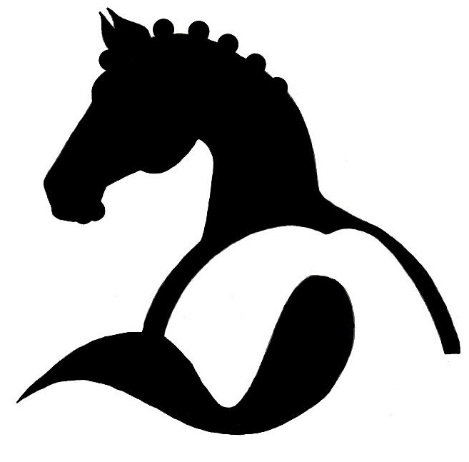
South West Pony
Association

SWPA SHOW RULES FOR AFFILIATED SHOWS

These Show Rules will be in place for our Championship Show.

You don’t have to use these rules for your show, but feel free to copy and use along with any individual rules regarding your particular show

1) Shows and Qualifying classes at Affiliated Shows to run under the rules of the South West Pony Association's general show rules, a copy
of which can be obtained from the Secretary, Miss Charise Broad, or downloaded from our website.

2) The organisers and SWPA accept NO responsibility for any accident, loss or damage to any competitors, spectators, animals or property.
It shall be a condition of entry that competitors will hold the organisers blameless and indemnify them against any loss, damage or legal proceedings.

3) All competitors take part at their OWN RISK and are expected to exercise due care at all times and obey all notices displayed.

4) The SWPA recommends that all exhibitors should have adequate personal sports insurance.

5) All shows affiliated to SWPA MUST have adequate Public Liability insurance, and Risk Assessment in place.

6) All accidents/incidents/falls should be reported to the Secretary of the individual show.

7) Exhibitors:
Exhibitors may not knowingly exhibit any Pony/Horse that has been bred, sold, leased or produced by the Judge, or his/her immediate family
or his/her employer, or from which financial gain has been made in the last two years. Exhibitors may be asked to produce documentation if required.
An exhibitor may not show an equine in a competition class judged by any member of his/her immediate family, may not show under a judge for whom he/she has produced an equine within two years of the current year date, and may not ride in a class judged by someone for whom he/she has ridden in a competition within two years of the current year date.
Exhibitors in both Ridden and In-Hand classes should wear NO Face and or Body Jewellery

8) Equines:
All Ridden Ponies MUST be 4 years old & over.
All Colts / Stallions two years old and over must be in possession of a current license, (unless otherwise governed by the individual Breed Society) and adequately bitted.
All Stallions MUST wear ‘Stallion Badges’ in all showing classes
In-Hand Stallions / Colts may NOT be led by any Juniors who have not attained their 14th birthday before 1st January in the current year.
Reins that restrict the natural movement of a pony/horse MUST not be used in the ring.
Snaffle Bridles only should be used in Lead Rein, First Ridden, Novice Ridden & Novice Ridden Working Hunter Classes. ‘Wilkie Bits’ may not be used as Snaffles and may not be used as part of a double bridle. (Details of acceptable Snaffle Bridles can be obtained from the (Secretary)
Mountain & Moorland ponies MUST be shown in their natural state and trimming MUST comply with the respective Pure Breed Society
Stud Books.
Mountain & Moorland ponies and Part Breds must be registered with their respective Pure Breed Societies and registration numbers to be stated on the entry forms and when entered on the day, (unless otherwise stated on the individual class). These conditions also apply to horses/ponies entered as Pure Bred, Part Bred & Anglo Arabs.
Mares with foals at foot MUST have attained their 4th birthday.
All foals being shown MUST be a minimum of three weeks old on the day of the show. No Foals to be Clipped, Lunged or shown Bitted. Mountain & Moorland Foals must be eligible for entry into their respective Pure Breed Society Stud Books.
SWPA recommend all equines are vaccinated against Equine Influenzas. We recommend Affiliated Shows check passports of all equines attending their show, and make exhibitors aware of any additional rules applied by the venues they use.

9) Riders / Handlers:
Any Pony Stallion not exceeding 138cms or Small Breed Mountain & Moorland Stallions may NOT be ridden by juniors who have NOT attained their 12th birthday before 1st January in the current year at any show affiliated to South West Pony Association. Stallions exceeding 138cms or Large Breed Mountain & Moorland Stallions may NOT be ridden by Juniors who have NOT attained their 14th birthday before 1st January in the current at any show affiliated to South West Pony Association. (unless otherwise governed by the individual Breed Society)
Junior Handlers of equines in all In-Hand classes, aged 14 years and under should wear correctly secured current British Standard skull caps/riding hats.
All Children MUST have attained their 3rd birthday by 1st January in the current year before competing in ANY ridden classes and must comply with the upper limit of the class entered and be prepared to supply a copy of their birth certificate if requested.
Riders MUST be within the correct age limits for the type of Horse/Pony ridden for the qualification to be valid.
In Ridden Classes, if a rider falls off at any time whilst in the ring, both pony/horse and rider MUST leave the ring, rider dismounted, and take no further part in the class.
Exhibitors in both Ridden and In-Hand classes should wear NO Face and or Body Jewellery

Continued: -
1

SWPA SHOW RULES FOR AFFILIATED SHOWS Continued:

9) Riders / Handlers Continued:
Correct Standard Headgear must comply with the following standards: PAS 015:2011, VG1 01.040 2014-12, ASTM F1163 2004a, SNELL E2016, AS/NZS 3838 32006 onwards, with BSI Kitemarking, or current standards to be worn at all times when mounted, with chinstraps from 3 points on the hat fastened.
NO Spurs to worn in any ridden class and Showing Canes MUST not exceed 30".
In Lead Rein classes the lead rein MUST be attached to the noseband only, and held in the Leader's Outside Hand.

10) Judges:
The Judges’ decision is final.

11) Welfare of Equines:
If an equine is deemed to be being mistreated in any way whilst at the show ground, the person or persons responsible may be asked to leave the show ground and may be reported to the authorities. The SWPA is also supporting the appropriate size/weight of rider for the equine they are riding.

12) Behaviour:
Behaviour by an exhibitor or his/her servants deemed unsporting or unreasonable, may be requested to leave the showground.
Any animal which in the opinion of the judge, is deemed out of control will be requested to leave the ring and/or the show ground.
Any exhibitors or their servants seen using social media to air disputes should be requested to remove all their exhibits from the showground and forfeit any entry fees paid.

13) Objections:
We advise that objections be made in writing to the secretary of your show within 30 minutes of the completion of the relevant class and accompanied with a fee of £15.00 (refundable if the objection is upheld)

If you have any queries regarding the rules, please contact Richard Broad on 07774 451156

2

